The Title of Your Manuscript
Author1 ^{a*}, Author2 ^{b}
ª Department, Organization, City, Country (first author's affiliation)
^{b} Department, Organization, City, Country (second author's affiliation)
ARTICLE INFO |  | ABSTRACT
Article history:  Received: 2024-10-08  Revised: 2025-03-16  Accepted: 2025-03-18 |  | This document provides guidelines for authors submitting manuscripts to the Journal of Artificial Intelligence in Science and Engineering. The abstract should be a single paragraph of 200 to 300 words, clearly outlining the paper's objective, aim, and results, including key findings and conclusions. Manuscripts must include a title page with a concise title and author information, followed by the abstract and 3 to 5 relevant keywords. The main sections should consist of a background, methods, results and discussion, and conclusions. Additional sections may include a list of abbreviations, competing interests, authors’ contributions, acknowledgements, and endnotes. References should be numbered in the order they appear in the text. Authors are required to submit their manuscripts online via the journal's submission portal and ensure compliance with formatting guidelines to facilitate the review process.
Keywords:
Include 3 to 5 keywords or phrases in separate lines.
Keyword 1;
Keyword 2;
Keyword 3;
Separated by semicolons.

Introduction
This document functions as a template developed in Microsoft Word, complete with predefined margins, column widths, line spacing, and type styles. Authors are invited to utilize this template by entering their text directly into it. This setup simplifies the manuscript preparation process, allowing users to focus on the content rather than formatting adjustments.
The introduction explains the aims of the manuscript. The history of research and results of previous works and their shortcoming should be mentioned here. Also, it provides theories and methods that are used in the manuscript. Figures and tables should not be inserted in the introduction section. A citation must be used for each sentence from other references. These references appear in the reference section at the end of the paper, in the order of their appearance. Citations should be numbered using square brackets like [1]. The Multiple references [2, 3] or a range of references [4-6] must be indicated within a single set of brackets. In sentences, refer simply to the reference number, like [7]. Do not use "Ref. [8]" or "reference [8]" except when you are beginning a sentence, for example: "Reference [8] shows ...".

Page Style
All paragraphs should be indented and justified in alignment. The font of the entire document should be Cambria.

Title and Author Details
Every word in a title must be capitalized except for words such as "a", "an", "and", "as", "at", "by", "for", "from", "if", "in", "into", "on", "or", "of", "the", "to", "with".
It should be noted any professional and official titles or academic degrees (Dr, chief, sir) must not show in Author details. In addition, the first name and the family name should be written in complete form.

Section Heading
Don't use more than three levels of headings, and those shouldn't be indented. For the third level of heading, use 10 pt fonts.

Footnotes
Footnotes should be avoided if possible. Necessary footnotes should be denoted in the text by consecutive superscript letters. The footnotes should be typed single-spaced and in smaller type size (8 pt), at the foot of the page in which they are mentioned, and separated from the main text by a short line extending at the foot of the column.

Figures and Tables
All figures and tables should be numbered with Arabic numerals and must be mentioned in the manuscript. They must be placed as close as possible to the first reference to them in the paper. In figures, numbers and captions should be typed below, and those should be typed above in tables. Figures and tables must be aligned in the center of the column and sized appropriately as width as one column.
Although, large figures and tables that take up more than 1 column width should be placed at the top or bottom of a page. For referring to figure or table, don't use bracket or parenthesis; for example, "Fig. 1 shows ...".

Figures
All photographs, schemas, graphs, and diagrams are referred to as figures. Low-quality scans are not acceptable. Figures must be embedded into the text and not supplied separately. Every figure has a caption that includes the figure number and a brief description. This caption must be enough perceptible without mention to the text
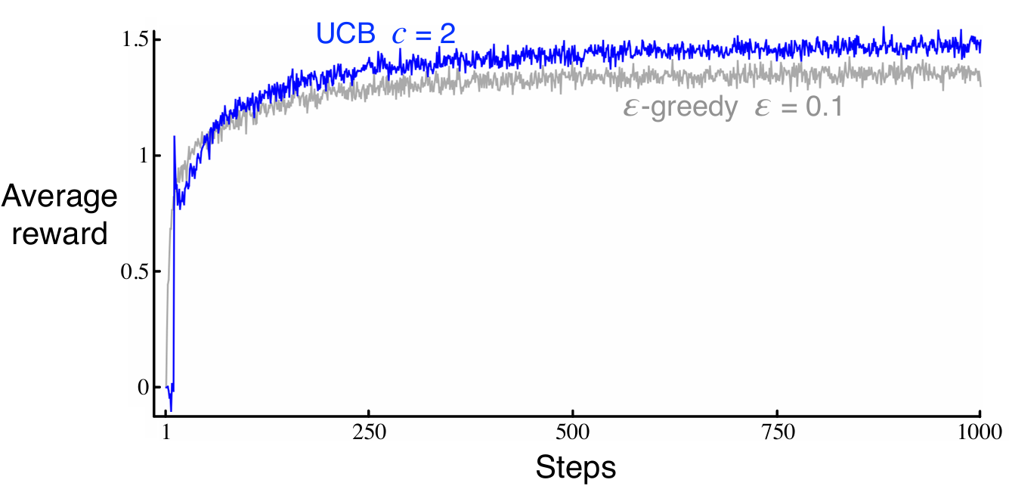
Fig. 1. This is a sample of a figure caption.
If figures or graphs are duplicated from other references, a citation should appear at the end of the caption.
Figure axis labels are often a source of confusion. Use words rather than symbols. As an example, write the quantity “Average Reward” or “Average Reward R,” not just “R.” Put units in parentheses. Do not label axes only with units.

Tables
Only horizontal lines should be used within a table, to distinguish the column headings from the body of the table, and immediately above and below the table. Tables must be embedded into the text.
Table 1. An example of a table
Column A | Column B | Column C
And an entry | 1 | 2
And another entry | 3 | 4
And another entry | 5 | 6
Details shouldn't appear in the caption of the tables. You can put them in footnotes. All tables, figures, and equations must be set in two-column format, except for large tables and figures or long equations that may span across both columns if necessary. Any table, figure, or equation that takes up more than one column width must be positioned either at the top or at the bottom of the page (e. g. Table 2. ).

Equations
Equations should be numbered consecutively throughout the paper. Equations and formulae should be typed by Microsoft Equation (insert-> symbols-> Equation) or MathType and numbered consecutively with Arabic numerals throughout the paper in parentheses on the right-hand side of the page (if referred to explicitly in the text):
$${\left(1+x\right)}^{n}=1+\frac{nx}{1!}+\frac{n\left(n-1\right)x^{2}}{2!}+…$$ | (1)
Be sure that the symbols in your equation have been defined before the equation appears or immediately following. When referring to an equation or formula, use simply “(1),” not “Eq. (1)” or “equation (1),” except at the beginning of a sentence: “Equation (1) is ... .”

Algorithms
Algorithms should be numbered and include a short title. They are set off from the text with rules above and below the title and after the last line.

Table 2. Thermal conductivity
No. | Metal | Thermal conductivity
No. | Metal | (Btu/(hr-ft-F)) | (W/(m.K)
1 | Silver | 247.87 | 429
2 | Copper | 231 | 399
3 | Gold | 183 | 316
4 | Aluminium | 136 | 235
5 | Yello brass | 69.33 | 120
6 | Cast iron | 46.33 | 80.1
7 | Stainless steal | 8.1 | 14.0

Conclusions
The conclusions may review the main points of the author's work. It could also include the application of the proposed method and suggestions for future research.

Acknowledgments
In General, the last paragraph of each paper is the place to acknowledge people and sponsors for dedicating and financial support. Company names and specific places should be cited only here.

Funding Statement
Please specify any sources of funding (institutional, private, and corporate financial support) for the work reported in their paper.

Conflicts of Interest
Authors must disclose all potential conflicts of interest in the manuscript, including financial, consultant, institutional and other relationships that might lead to bias or a conflict of interest. If there is no conflict of interest it should be stated as: The author declares that there is no conflict of interest regarding the publication of this article.

Appendixes
Appendixes appear after Conflicts of Interest.

References
Basic format for periodicals:
J. K. Author, “Name of paper,” Abbrev. Title of Periodical, vol. x, no. x, pp. xxx-xxx, Abbrev. Month, year, doi: 10.1109.XXX.1234567.

Periodicals using article numbers:
J. K. Author, “Name of paper,” Abbrev. Title of Periodical, vol. x, no. x, Abbrev. Month, year, Art. no. xxxxx, doi: 10.1109.XXX.1234567.

Examples:
[1] J. U. Duncombe, “Infrared navigation—Part I: An assessment of feasibility,” IEEE Trans. Electron Devices, vol. ED-11, no. 1, pp. 34–39, Jan. 1959, doi: 10.1109/TED.2016.2628402.
[2] E. P. Wigner, “Theory of traveling-wave optical laser,” Phys. Rev., vol. 134, pp. A635–A646, Dec. 1965.
[3] P. Kopyt et al., “Electric properties of graphene-based conductive layers from DC up to terahertz range,” IEEE THz Sci. Technol., to be published, doi: 10.1109/TTHZ.2016.2544142. (Note: If a paper is still to be published, but is available in early access, please follow ref [5]).)
[4] R. Fardel, M. Nagel, F. Nuesch, T. Lippert, and A. Wokaun, “Fabrication of organic light emitting diode pixels by laser-assisted forward transfer,” Appl. Phys. Lett., vol. 91, no. 6, Aug. 2007, Art. no. 061103.
[5] D. Comite and N. Pierdicca, "Decorrelation of the near-specular land scattering in bistatic radar systems," IEEE Trans. Geosci. Remote Sens., early access, doi: 10.1109/TGRS.2021.3072864. (Note: This format is used for articles in early access. The doi must be included.)
[6] H. V. Habi and H. Messer, "Recurrent neural network for rain estimation using commercial microwave links," IEEE Trans. Geosci. Remote Sens., vol. 59, no. 5, pp. 3672-3681, May 2021. [Online]. Available: https://ieeexplore.ieee.org/document/9153027

Basic format for books:
J. K. Author, “Title of chapter in the book,” in Title of Published Book, xth ed. City of Publisher, (only U.S. State), Country: Abbrev. of Publisher, year, ch. x, sec. x, pp. xxx–xxx.

Examples:
[7] G. O. Young, “Synthetic structure of industrial plastics,” in Plastics, 2nd ed., vol. 3, J. Peters, Ed. New York, NY, USA: McGraw-Hill, 1964, pp. 15–64.
[8] W.-K. Chen, Linear Networks and Systems. Belmont, CA, USA: Wadsworth, 1993, pp. 123–135.
[9] Philip B. Kurland and Ralph Lerner, eds., The Founders’ Constitution. Chicago, IL, USA: Univ. of Chicago Press, 1987, Accessed on: Feb. 28, 2010, [Online]. Available: http://press-pubs.uchicago.edu/founders/

Basic format for handbooks:
Name of Manual/Handbook, x ed., Abbrev. Name of Co., City of Co., Abbrev. State, Country, year, pp. xxx-xxx.

Examples:
[10] Transmission Systems for Communications, 3rd ed., Western Electric Co., Winston-Salem, NC, USA, 1985, pp. 44–60.
[11] Motorola Semiconductor Data Manual, Motorola Semiconductor Products Inc., Phoenix, AZ, USA, 1989.
[12] R. J. Hijmans and J. van Etten, “Raster: Geographic analysis and modeling with raster data,” R Package Version 2.0-12, Jan. 12, 2012. [Online]. Available: http://CRAN.R-project.org/package=raster

Basic format for reports:
J. K. Author, “Title of report,” Abbrev. Name of Co., City of Co., Abbrev. State, Country, Rep. xxx, year.

Example:
[13] E. E. Reber, R. L. Michell, and C. J. Carter, “Oxygen absorption in the earth’s atmosphere,” Aerospace Corp., Los Angeles, CA, USA, Tech. Rep. TR-0200 (4230-46)-3, Nov. 1988.

Basic format for conference proceedings:
J. K. Author, “Title of paper,” in Abbreviated Name of Conf., City of Conf., Abbrev. State (if given), Country, year, pp. xxxxxx.

Examples:
[14] D. B. Payne and J. R. Stern, “Wavelength-switched passively coupled single-mode optical network,” in Proc. IOOC-ECOC, Boston, MA, USA, 1985, pp. 585–590.
[15] D. Ebehard and E. Voges, “Digital single sideband detection for interferometric sensors,” presented at the 2nd Int. Conf. Optical Fiber Sensors, Stuttgart, Germany, Jan. 2-5, 1984.
[16] PROCESS Corporation, Boston, MA, USA. Intranets: Internet technologies deployed behind the firewall for corporate productivity. Presented at INET96 Annual Meeting. [Online]. Available: http://home.process.com/Intranets/wp2.htp

Basic format for electronic documents (when available online):
Issuing Organization. (year, month day). Title. [Type of medium]. Available: site/path/file

Example:
[17] U.S. House. 102nd Congress, 1st Session. (1991, Jan. 11). H. Con. Res. 1, Sense of the Congress on Approval of Military Action. [Online]. Available: LEXIS Library: GENFED File: BILLS

Basic format for patents:
J. K. Author, “Title of patent,” U.S. Patent x xxx xxx, Abbrev. Month, day, year.

Example:
[18] G. Brandli and M. Dick, “Alternating current fed power supply,” U.S. Patent 4 084 217, Nov. 4, 1978.

Basic format for theses (M.S.) and dissertations (Ph.D.):
J. K. Author, “Title of thesis,” M.S. thesis, Abbrev. Dept., Abbrev. Univ., City of Univ., Abbrev. State, year.
J. K. Author, “Title of dissertation,” Ph.D. dissertation, Abbrev. Dept., Abbrev. Univ., City of Univ., Abbrev. State, year.

Examples:
[19] J. O. Williams, “Narrow-band analyzer,” Ph.D. dissertation, Dept. Elect. Eng., Harvard Univ., Cambridge, MA, USA, 1993.
[20] N. Kawasaki, “Parametric study of thermal and chemical nonequilibrium nozzle flow,” M.S. thesis, Dept. Electron. Eng., Osaka Univ., Osaka, Japan, 1993.

Basic format for the most common types of unpublished references:
J. K. Author, private communication, Abbrev. Month, year.
J. K. Author, “Title of paper,” unpublished.
J. K. Author, “Title of paper,” to be published.

Examples:
[21] A. Harrison, private communication, May 1995.
[22] B. Smith, “An approach to graphs of linear forms,” 2014, arXiv:2105.02824.
[23] A. Brahms, “Representation error for real numbers in binary computer arithmetic,” IEEE Computer Group Repository, Paper R-67-85.

Basic formats for standards:
a) Title of Standard, Standard number, date.
b) Title of Standard, Standard number, Corporate author, location, date.

Examples:
[24] IEEE Criteria for Class IE Electric Systems, IEEE Standard 308, 1969.
[25] Letter Symbols for Quantities, ANSI Standard Y10.5-1968.

Basic format for datasets:
Author, Date, Year. “Title of Dataset,” distributed by Publisher/Distributor, http://url.com (or if DOI is used, end with a period)

Example:
[26] U.S. Department of Health and Human Services, Aug. 2013, “Treatment Episode Dataset: Discharges (TEDS-D): Concatenated, 2006 to 2009,” U.S. Department of Health and Human Services, Substance Abuse and Mental Health Services Administration, Office of Applied Studies, doi: 10.3886/ICPSR30122.v2.

Basic format for code:
Author, Date published or disseminated, Year. “Complete title, including ed./vers.#,” distributed by Publisher/Distributor, http://url.com (or if DOI is used, end with a period)

Example:
[27] T. D’Martin and S. Soares, 2019, “Code for Assessment of Markov Decision Processes in Long-Term Hydrothermal Scheduling of Single-Reservoir Systems (Version 1.0),” Code Ocean, doi: _1.24433/CO.7212286.v1

